User manual for Author

- Start using the journal review system
- Register account
After entering the academic journal system first, there will be a link to submit the online submission on the website. Please click to submit the submission. Usually, you will see the following screen, showing the current activities of the journal.
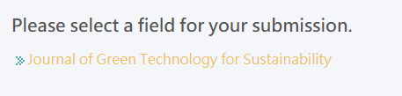

After clicking, you will be asked to log in first. If you do not have an account yet, please register one first.
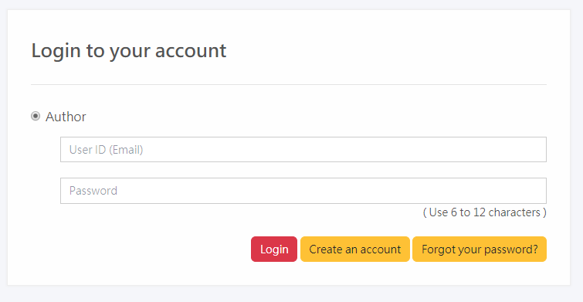
You must fill in the following information before you can complete the account registration. Email must be checked correctly. System notifications are based on this email.

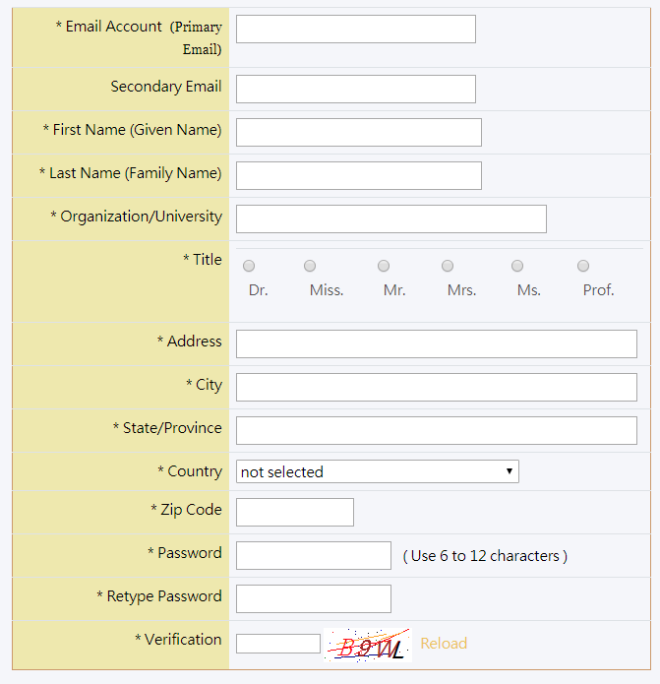

After logging in, the first page will see the to-do list page. Since you have just registered your account, the system's to-do list is currently empty.

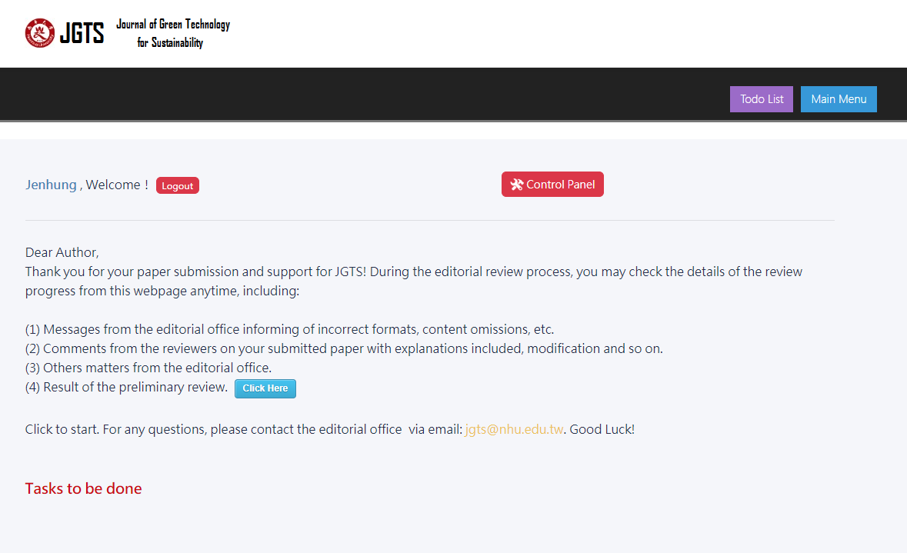
- To-do list
Because the process of reviewing the manuscript is very long, a paper has been processed by the author, editorial office, editor, review board, and editor-in-chief. Once a person forgets to process it in a few months, the process time will be prolonged.
So we set up the to-do list function for each system role so that everyone can clearly know what they are not doing at the moment.

As shown in the figure below, you don't have to remember what has not been processed yet. The system will automatically pick you up and list it as a to-do list. You only need to press the [Process] button, the system will take you to the corresponding function. The to-do list will be automatically lifted.

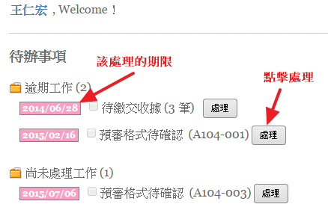

- Start contributing
In addition to the link to submit the manuscript on the homepage of the website, you can also log in to the contributor's back office and use the system's submission function to submit the manuscript.
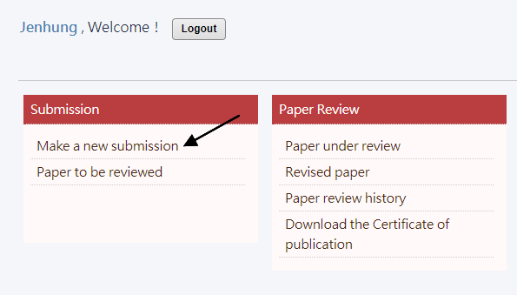

The system will display the invitation theme currently open for you to choose

After clicking, there will be a consent statement, you must check the agreement to proceed to the next step.

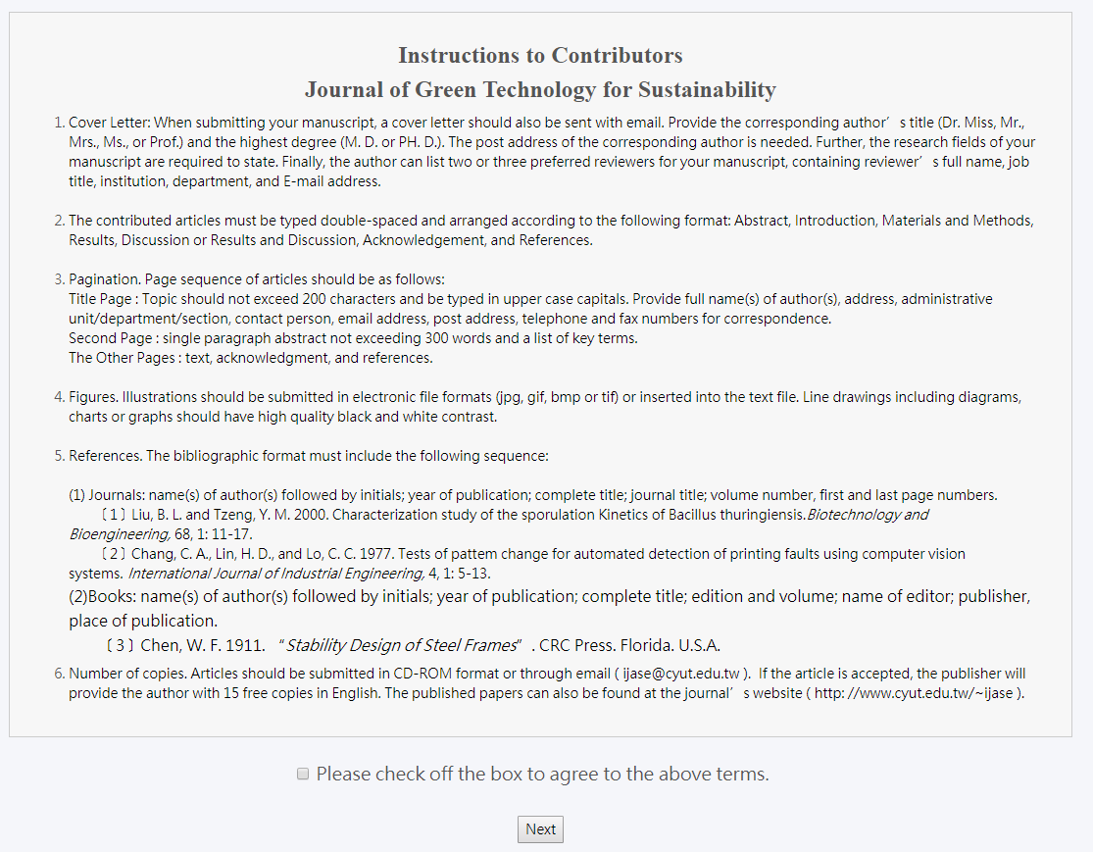

Next, start contributing work.
Step 1
fill in the relevant information of the paper. If the field is a required field, the system will remind you of the missing information.

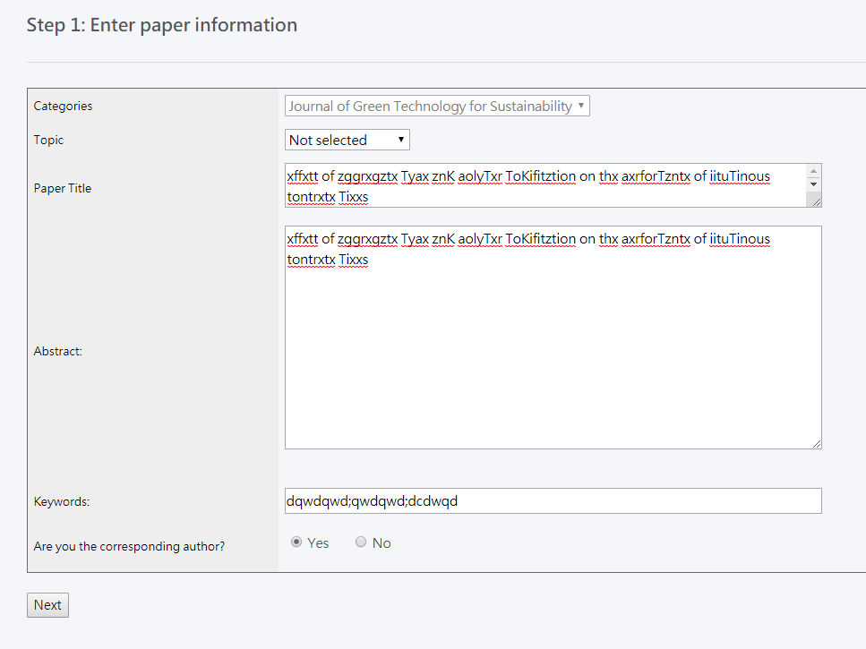

Step 2
Fill in the information of the co-author
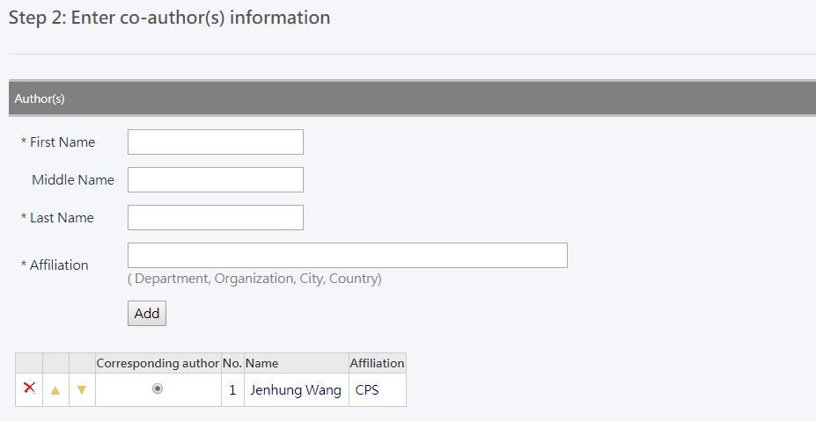
You can enter multiple author data, which can be sorted by the up and down buttons after input, or re-entered after X is deleted.

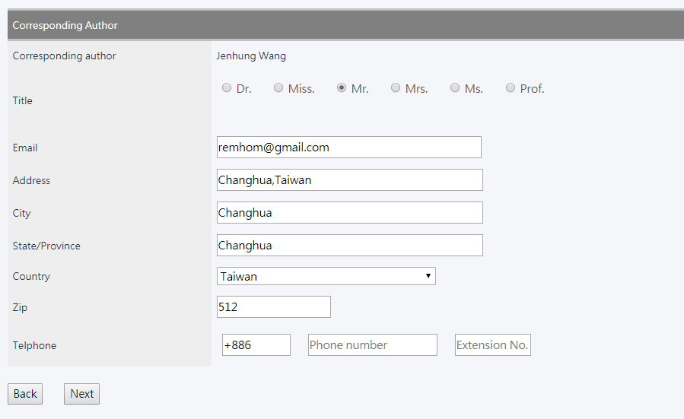

Final Step
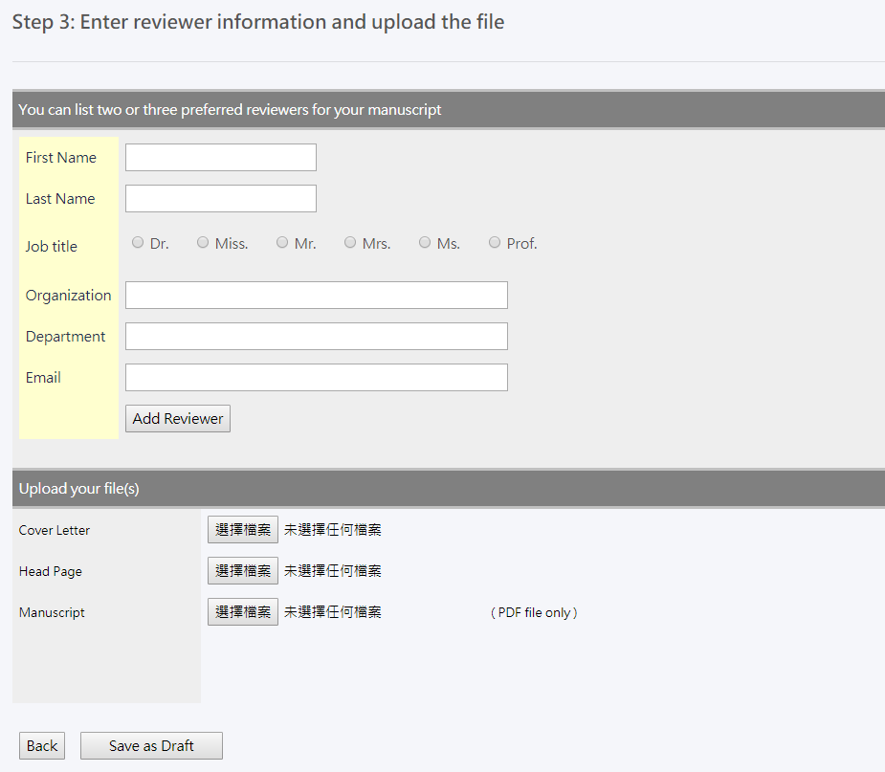
After uploading the required materials for submission, you can press the temporary storage and the system will enter the final confirmation screen.
After the temporary storage, the system will bring it to the editing screen again, allowing you to quickly browse the information you just filled in. If there is no problem, press the send button, the system will officially take the draft of the draft paper and notify the editorial staff. Anonymous review.

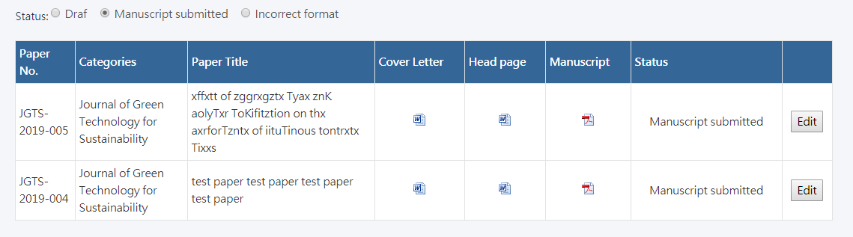
After being sent to the editorial office, the status of your paper will be converted into a formal review. The editorial office will submit the review if it meets the formal requirements after the review. If it does not, you will be notified by letter to modify it again.

- Post-review, amendment, and publication
After your paper is sent to a professional review board for external review, after a cautious review process, your paper is judged to be published after revision or revised and then reviewed. At this time, the system will send you a notice letter, please Review comments for defense.
When you receive the letter, enter the system, you will see the paper that needs to be revised and re-examined, please click on the process.

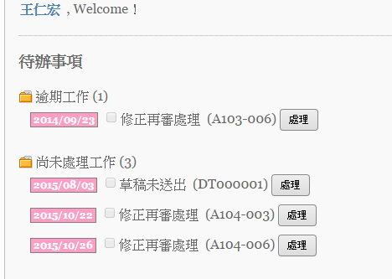

After entering the post screen, please click on the paper to be processed.
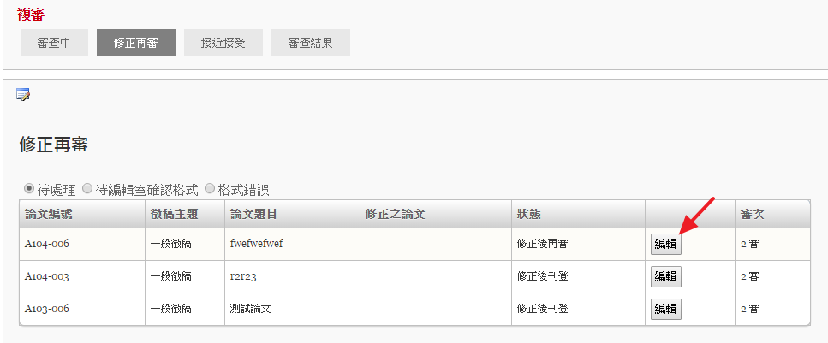

- Publishing school draft work
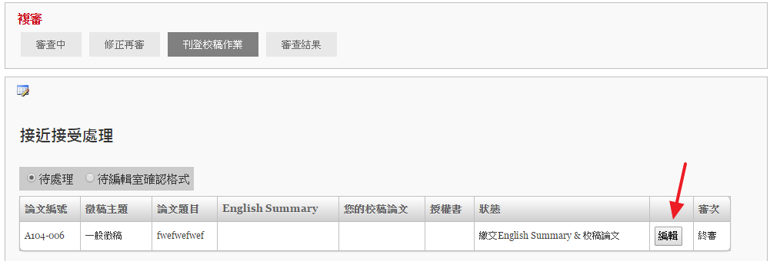
When your paper is accepted, you will be published for the publication of the manuscript.

In the proofing operation, the editorial office will continue to give revisions to your papers in order to conform to the format required for publication.

You can also suggest your thoughts about the content of the proof, and by doing so, you can provide the information you need to publish your homework.
